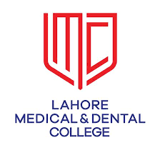

**STUDY GUIDE BDS**

**DEPARTMENT OF MEDICINE**



**LAHORE MEDICALAND DENTAL COLLEGE**

**CONTENTS**

1. **Introduction**
2. **Purpose of Guide**
3. **Learning Audiences**
4. **Learning Objectives**
5. **Duration of session**
6. **Departmental staff hierarchy/ plan**
7. **Alignment of education with study hours (Third year BDS)**
8. **Departmental Timetables**
9. **Content/Syllabus (PMDC)**
10. **Teaching & Learning Methodologies**
11. **Learning Resources**
12. **Assessments Methods**
13. **Roubust Feedback System**
14. **Councelling**

**INTRODUCTION**

Medical education is a life-long process and BDS curriculum is a part of the continuum of education from pre-medical education, BDS, proceeding to house job, and post-graduation. PM&DC outlines the guiding principles for undergraduate medical curriculum and has defined the generic competencies and desired outcomes for a medical graduate to provide optimal health care, leading to better health outcomes for patients and societies. These generic competencies set the standards of care for all physicians and form a part of the identity of a doctor. Each competency describes a core ability of a competent physician. This study guide will give an insight to the students about all these competencies and how to plan their educational activities in the subject of medicine during third year BDS.

**PURPOSE OF GUIDE:** To facilitatelearning of the studentby educating them about organization of the learning program, facilitate students in managing their studies through the academic year and guidance on assessments methods, exam rules and regulations.

**TARGET AUDIENCE**

3RD year BDS students

**LEARNING OBJECTIVES *(knowledge, skills, attitude)***

1. to equip the students with specific knowledge, essential skills and appropriate attitude towards the human body not just focusing on oral cavity
2. to become problem solvers, dealing effectively with familiar and unfamiliar problems
3. to become lifelong learners
4. to direct their own learning and evaluate this activity
5. to be able to reason critically and make justifiable decisions regarding patient management
6. to practice evidence-based medicine
7. to always ensure patient safety
8. to ensure compliance with the legal system as it impacts health care and the PM&DC regulations
9. to adopt a multidisciplinary approach for health promoting interventions
10. to be able to demonstrate professional values of self and professional accountability, honesty, probity, and ethics
11. to be able to demonstrate exemplary professional conduct
12. to be able to understand the pathogenesis of specific diseases
13. to be able to take a thorough focused history and identify the patient’s risk factors related to the disease process
14. to be able to perform a physical examination on a patient, to diagnose specific diseases and rule out other diseases
15. to formulate a provisional diagnosis with justification, and the likely differential diagnoses
16. to be able to select appropriate hematological, biochemical and microbiological investigations and interpret their reports to confirm the diagnosis
17. to be able to select specific radiological investigations for specific diseases
18. to be able to apply evidence-based medicine concepts for the medical treatment of different diseases
19. to be able to write prescriptions in appropriate format according to the disease

**TEACHING METHODOLOGIES FOR MEDICINE**

1. Interactive Lectures
2. Tutorials
3. Case based learning(CBL)
4. Essential Skills to be learned in the skills lab
5. Power point presentations by students
6. Small group discussions
7. Clinical ward rotations
8. CPC’s – using modern audio-visual techniques, distant learning using electronic devices and current Information technology facilities
9. Self-directed learning is the most vital part of this module to solve problematic cases, go through different learning resources and discuss with peers and the faculty to clarify difficult concepts

**ATTENDANCE REQUIREMENT FOR MEDICINE AND ALLIED**

1. Students are expected to attend all scheduled teaching sessions and examinations
2. Attendance in lectures, tutorials, and wards is mandatory. Absence from these sessions will make the students ineligible to sit the final summative assessment.
3. A minimum of 75 % attendance in the lectures and wards is mandatory to appear in the summative UHS examination
4. Attendance will be recorded through a log-in/log-out biometrics system
5. Absence due to illness must be certified appropriately by the General Physician

**DURATION OF SESSION:** 11th April 2022 – 14th January 2023

**DEAPRTMENTAL STAFF HIERARCHY/ PLAN**

**HIRARCY DEPARTMENT OF MEDICINE**

**DENTAL SECTION**

**COURSE TO BE STUDIED (syllabus)**

The course outline is as follows:

By the third year BDS, students should be able to identify and discuss the common causes of common clinical presentations. Causes in detail can be discussed under various other headings.

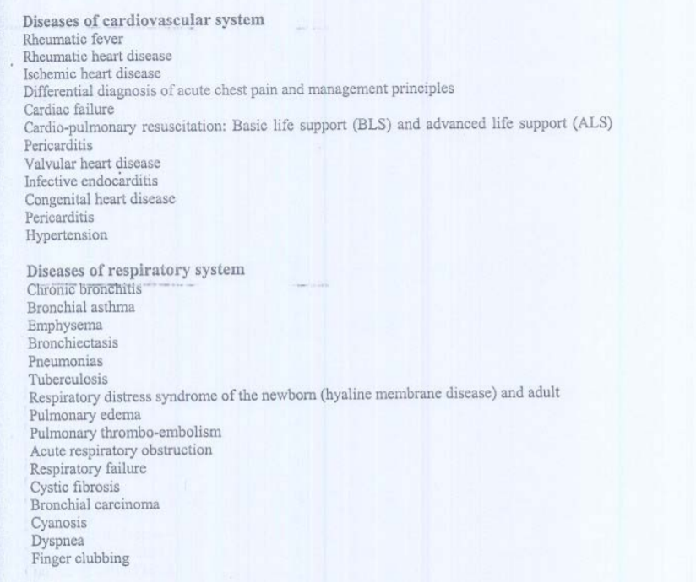

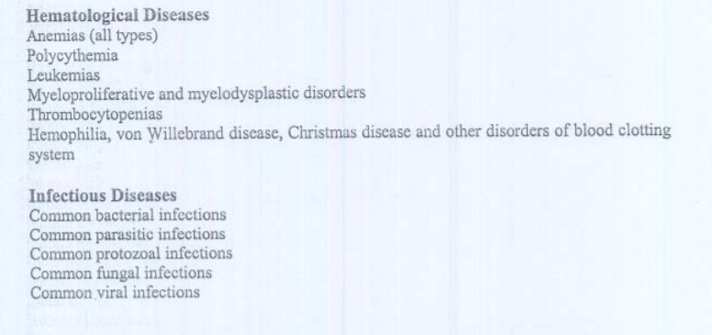

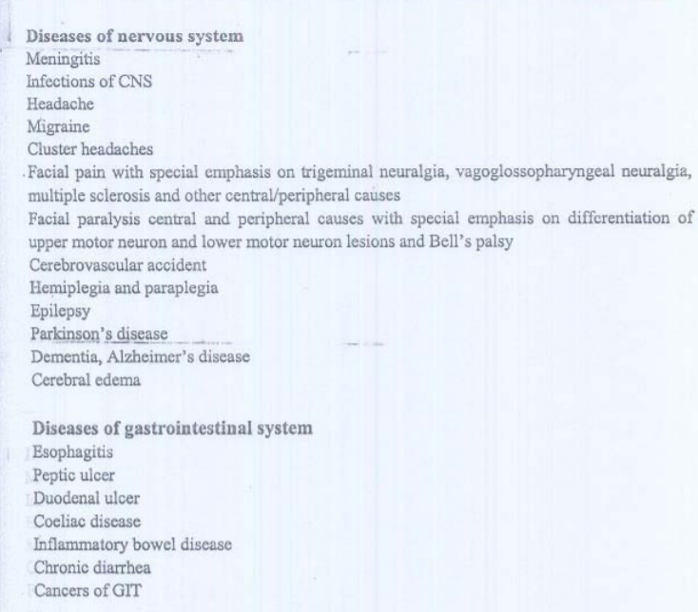

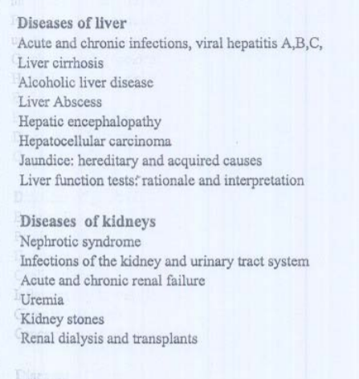

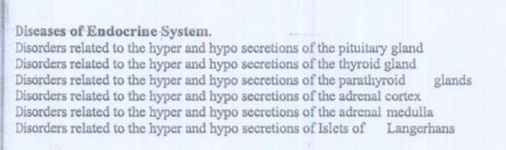

**ALIGNMENT OF EDUCATION WITH STUDY HOURS (3rd year BDS )**

Session Length: 10 months

Lectures

2 lectures/week; 45 min each

[90 min (1.5 hours) each week = 60 hours per session

|  |  |  |
| --- | --- | --- |
|  | PMDC Hours | LMDC Hours |
| Lectures | 50 | 60 |

Wards

*Morning*

3 hours per day; 2 days a week (10 months)

Each student will attend medicine ward for 5 months

Each student will attend 120 hours of morning wards

*Evening*

3 hours per day; 2 days a week (2 classes / week; 10 classes in 5 weeks)

|  |  |  |
| --- | --- | --- |
|  | PMDC Hours | LMDC Hours |
| Wards (Practical) | 150 | 120+30=150 |

**DEPARTMENTAL TIMETABLES**

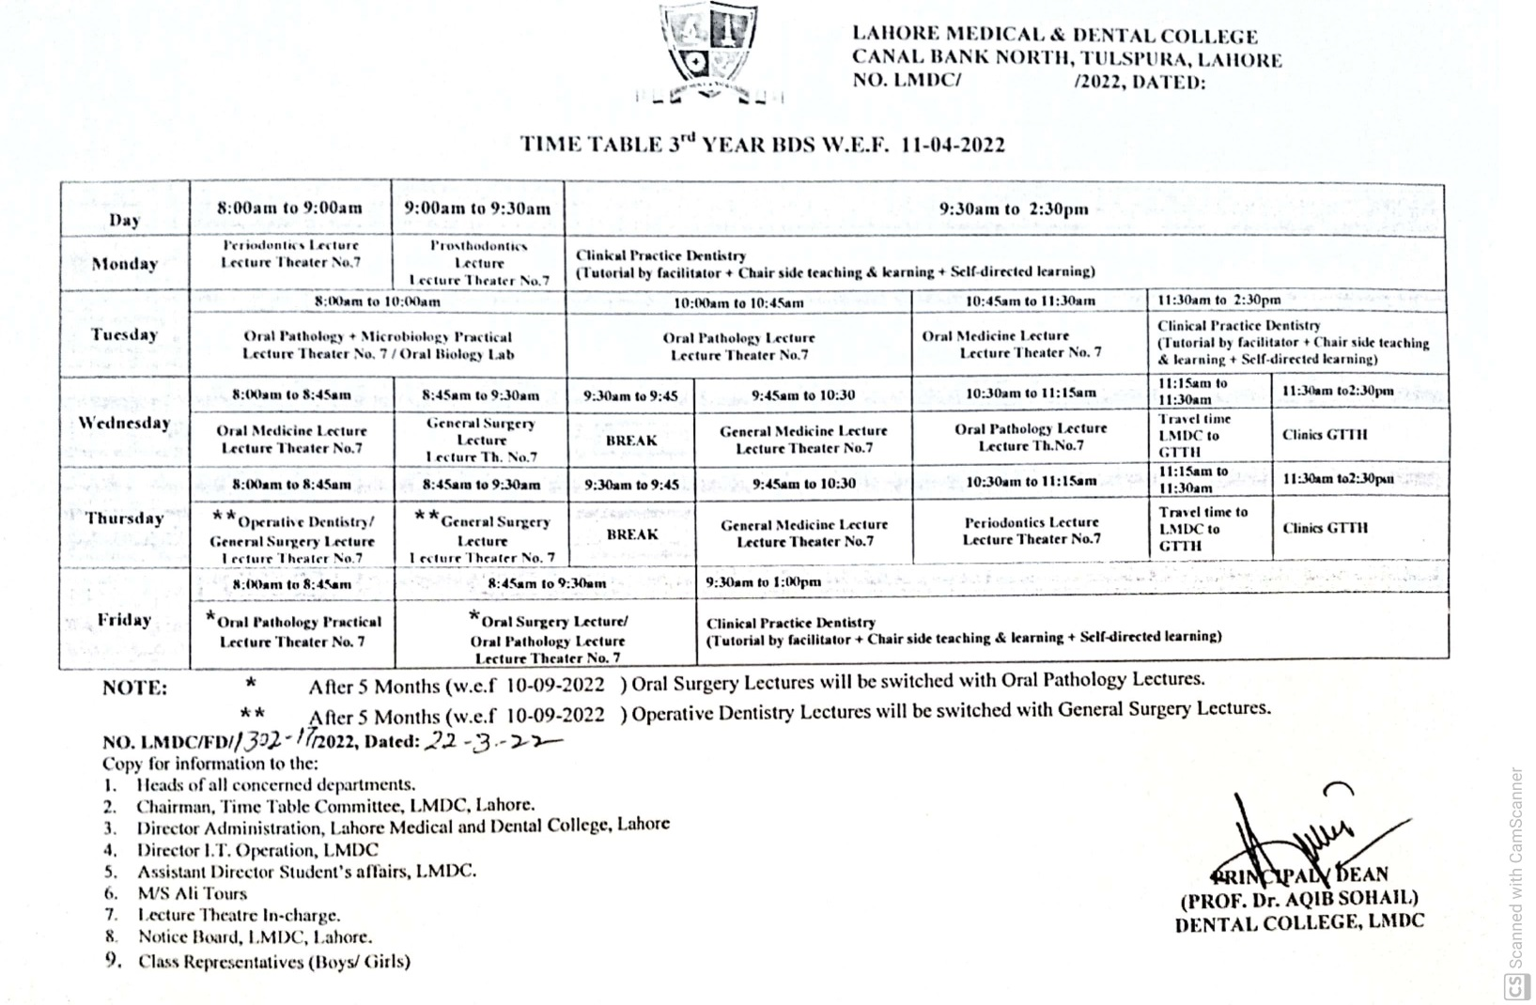

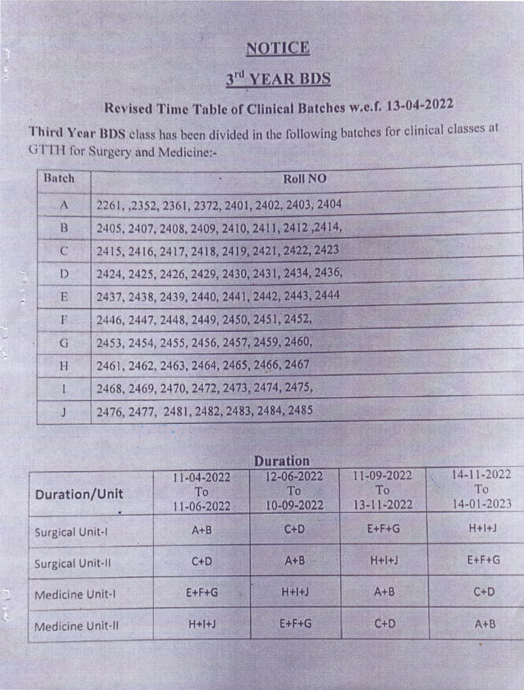

**ASSESSMENT METHODOLOGY**

***Formative***

**Theory,** single best multiple choice question and SEQ test at the end of each topic finished and all topics tests at end of session

**Clinical ward test,** comprising of one long case (100 marks) and one OSCE comprising of 10 stations (30 marks), 25 marks contributed by ward attendance and histories taken

Total marks= 200

**MARKS UHS PAPER**

The examination in the subject of General Medicine shall be as follows:-

I. One written paper of 90 marks in General Medicine having two parts:

i. Part I shall have 45 Multiple Choice Questions (MCQs) of 45 marks and the time allotted shall be forty five minutes.

ii. Part II shall have fifteen Short Essay Questions (SEQs) of 45 marks and the time allotted shall be two hours and fifteen minutes.

II. Oral and Practical examination shall have 90 marks.

III. The continuous internal assessment shall carry 20 marks i.e 10% of the total allocated marks for the subject. The score will be equally distributed to the theory and practical examinations.

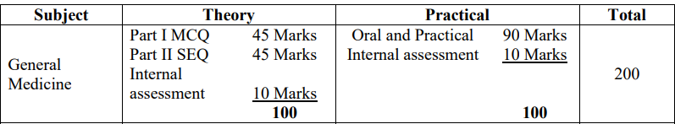

**LEARNING RESOURCES**

***Recommended books***

1. Davidson’s Principals and Practices of Medicine.
2. Kumar and Clark’s Clinical Medicine
3. Essentials of clinical medicine by Prof Wasim Amer
4. Macleod’s clinical methods
5. Online Journals and Reading Materials through HEC Digital Library Facility.

***Technologies to be used***

1. Textbooks are the most important part of student learning for this subject
2. Bed side learning with patients
3. Demonstration of clinical methods
4. Hands-on activities and practical sessions to enhance the learning.
5. Skills lab will be used for simulated learning of the basic skills related to the gastrointestinal system
6. Videos from different web portals to familiarize the students with the procedures and protocols.
7. Computer and Internet resources are essential to gather the latest information about a specific disease.

**ROBUST FEEDBACK SYSTEMS:**

* Feedback on attendance report is forwarded to students and parents on daily basis.
* Feedback on academic performance Academic performance report is also regularly forwarded to students and parents.
* Individual students are given feedback on their academic performance in one to one session.
* MCQ and SEQ papers are also discussed with students in small groups. Parents of weak students are regularly contacted.

**COUNSELLING**

For students will include

* **Career Guidance**
* **Psychosocial Counselling**

COUNSELING FACILITIES FOR STUDENTS:

* Senior faculty members of Medicine department are actively involved in resolving academic and non-academic issues of allocated students.
* Individual students are also referred to the student counselor, if needed