

**DEPARTMENT OF ANAESTHESIA & PAIN MEDICINE**

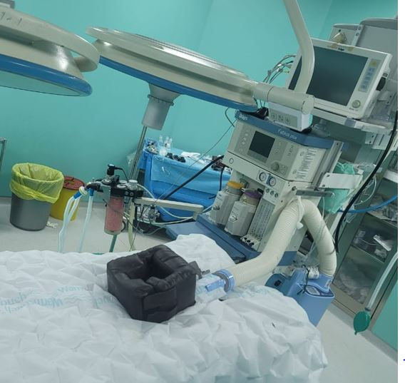

**LAHORE MEDICAL AND DENTAL COLLEGE**

**CONTENTS**

1. Introduction
2. Purpose of Guide
3. Target Audience
4. Learning Audiences
5. Learning Objectives
6. Teaching methodologies for Anaesthesia
7. Attendance requirement for medicine and allied
8. Duration of session
9. Departmental staff hierarchy/ plan
10. Alignment of education with study hours (Final year MBBS)
11. Content/Syllabus (PMDC)
12. Departmental time tables
13. Teaching & Learning Methodologies
14. Learning Resources
15. Assessments Methods
16. Table of specification for Anaesthesia exam
17. Online teaching
18. Robust feedback systems
19. Counselling facilities for students

**INTRODUCTION**

Medical education is a continuous process that begins with pre-medical education and continues through MBBS, house jobs, and post-graduation. The MBBS curriculum is a component of this continuum. The PM&DC describes the guiding principles for undergraduate medical education and has identified the general competences and intended results for a medical graduate to offer optimal health care, resulting in better health outcomes for patients and society. These fundamental skills are a component of a doctor's identity and establish the minimum standards of care for all doctors. Each competence explains a fundamental skill possessed by an effective doctor. The students will get knowledge of all these abilities and learn how to organize their academic pursuits in the field of anesthesia for their final year after reading this study guide.

**PURPOSE OF GUIDE:**

To help undergraduate students study the topic of anesthesia effectively, by educating them on how the learning program is organized, assisting students in managing their academic workload during the academic year, providing advice on assessment strategies and exam rules and regulations.

**TARGET AUDIENCE**

03rd - 5th year MBBS students

**LEARNING OBJECTIVES *(knowledge, skills, attitude)***

1. to equip the students with specific knowledge, essential skills and appropriate attitude towards the specialty of anaesthesia
2. to become problem solvers, dealing effectively with familiar and unfamiliar problems
3. to become lifelong learners
4. to direct their own learning and evaluate this activity
5. to be able to reason critically and make justifiable decisions regarding patient management
6. to practice evidence-based medicine
7. to always ensure patient safety
8. to ensure compliance with the legal system as it impacts health care and the PM&DC regulations
9. to adopt a multidisciplinary approach for health promoting interventions
10. Medical graduates should be able to demonstrate professional values of self and professional accountability, honesty, probity, and ethics
11. Medical graduates are expected to demonstrate exemplary professional conduct
12. to be able to determine the risk stratification of Anaesthesia regarding various surgeries

1. to be able to select appropriate hematological, biochemical and microbiological investigations and interpret their reports for risk stratification for anesthesia
2. to be able to select specific radiological investigations for specific diseases
3. to be able to apply perioperative concepts for optimization
4. to be able to write perioperative plan in appropriate format
5. to keep patients pain free preoperatively
6. management of indoor & outdoor pain

**TEACHING METHODOLOGIES FOR ANAESTHESIA**

1. Interactive Lectures

2. Student presentations

1. Case based learning
2. Tutorials
3. Essential Skills
4. Small group discussions
5. Pain clinic & preop clinic opd
6. CPC’s – using modern audio-visual techniques, distant learning using electronic devices and current Information technology facilities
7. Journal Club meetings
8. Self-directed learning is the most vital part of this module to solve problematic cases, go through different learning resources and discuss with peers and the faculty to clarify difficult concepts

**ATTENDANCE REQUIREMENT**

1. Students are expected to attend all scheduled teaching sessions and examinations
2. Attendance in lectures, tutorials, is mandatory.
3. A minimum of 75 % attendance in the lectures and wards is mandatory to appear in the summative UHS examination
4. Attendance will be recorded through a log-in/log-out biometrics system

**DEAPARTMENTAL CONSULTANTS / HIERARCHY PLAN**

Anaesthesia department teaching staff consists of:

1. Professor Leena Aziz (Head of Department)

2. Dr. Noman Tariq (Associate Professor)

3. Dr. Shahid Rasool Dar (Assistant Professor)

4. Dr. Waseem Younis (Senior Registrar)

**Syllabus**

The course outline is as follows:

The students will be taught all these topics.

|  |
| --- |
| **Introduction and Basics of Anaesthesia** |
| Introduction and History taking |
| Anatomy and Physiology of various system |
| Basic resuscitation technique |
| Airway Management |
| **Cardiac Concerns** |
| Hypertension |
| CCF |
| Pacemaker / IHD |
| Valvular heart disease |
| **Respiratory Concerns** |
| Asthma |
| COPD |
| Tuberculosis |
| Lung pathologies |
| **Renal Concerns** |
| AKI |
| CKD |
| Renal Failure |
| **Hematologic** |
| Hemophilia's |
| Transfusion reaction |
| Blood loss calculation |
| IV Fluids |
| **Infections** |
| Bacterial infections (Staphylococcal/Streptococcal) |
| Fungal infections |
| Sterilization |
| Hepatitis B,C , HIV |
| PPE |
| **Pain Management** |
| Acute Pain Management |
| Chronic Pain Management |
| Multimodal Pain Management |

**ASSESSMENT METHODOLOGY**

***Formative***

**Theory,** single best multiple choice questions at the end of each topic completed. MCQs and SEQs for all topics tests at end of session.

**Clinical ward test,** comprising of 10 MCQs,1 SEQ and viva voce contributed by ward attendance and histories taken

Total marks= 100

**Summative UHS examination (to be held at the end of 5th year MBBS)**

Anaesthesia will be a part of Paper-II (medicine).

It will include: 1. Introduction and Basics of Anaesthesia 2. Application 3.Complication 4. Type5. Airway Management 6. Reactions 7. Systemic Concerns 8. General Anaesthesia 9. Regional Anaesthesia 10. Pain Management

**Summative examination details**

Anaesthesia will be a part of Medicine paper-II The paper will have the portion of Anaesthesia in the following pattern

**6 MCQs……1 marks each**

**1 SEQ……...5 marks each**

**TIMETABLE 5th Year MBBS**

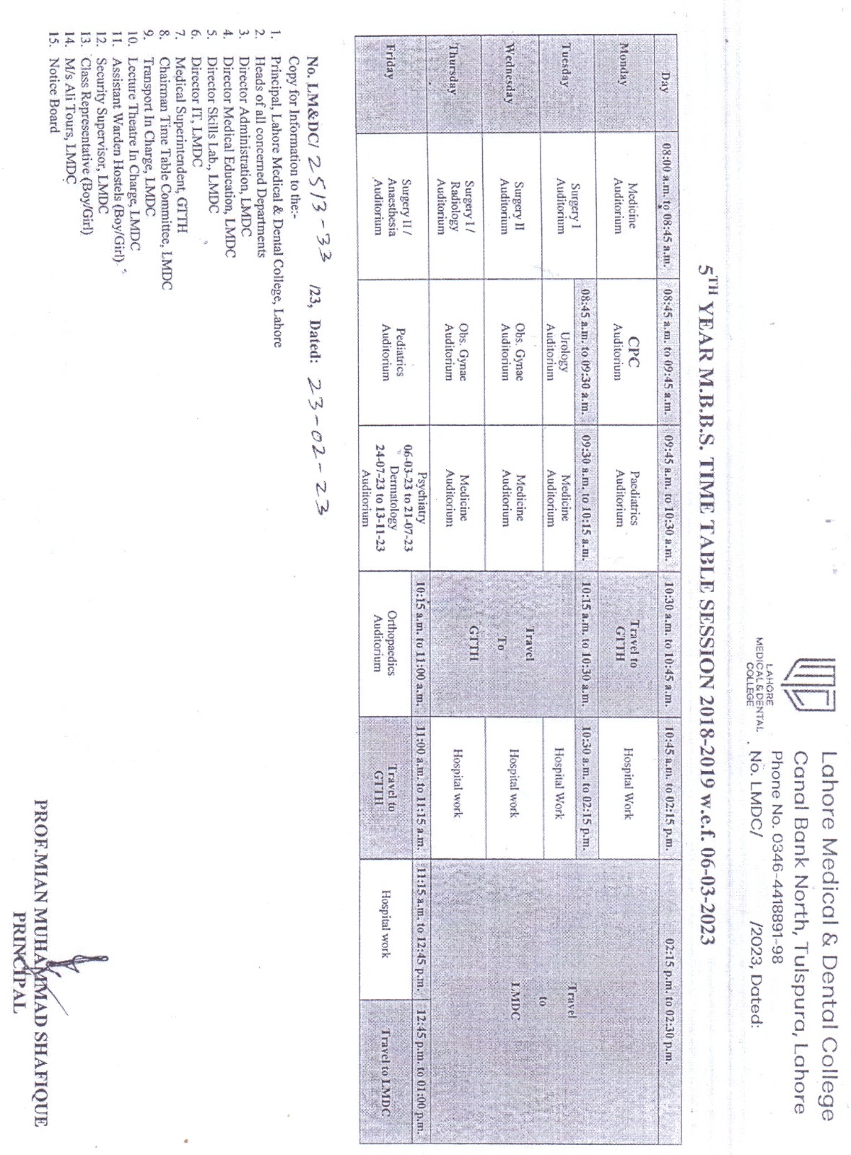

**Timetable**

**LEARNING RESOURCES**

***Recommended books***

1. Basic of Anaesthesia Smith & Aitken head's.
2. Davidson’s Principles and Practices of Medicine.
3. Kumar and Clark’s Clinical medicine.

***Technologies to be used***

1. Textbooks are the most important part of student learning for this subject
2. Preop Clinic & Pain Clinic
3. Hands-on activities and practical sessions to enhance the learning.
4. Skills lab will be used for simulated learning of the basic skills related to the skin
5. Videos and slides from different web portals to familiarize the students with the procedures and protocols.
6. Computer and Internet resources are essential to gather the latest information about a specific disease.

**TABLE OF SPECIFICATION FOR MEDICINE EXAM**

**Anaesthesia will be included in medicine-II. 1 SEQ and 6 MCQs will be the part of the paper.**

|  |  |  |
| --- | --- | --- |
| S.NO | TOPIC | MCQs |
| 1 | **Introduction and basics of Anaesthesia** | 01 |
| 2 | **Complications of Anaesthesia** | 01 |
| 3 | **Airway management** | 01 |
| 4 | **Types of Anaesthesia** | 01 |
| 5 | **Prevention of infection & Sterilization** | 01 |
| 6 | **Cardio Pulmonary Resuscitation** | 01 |

**\*1 SEQ will come from any of the aforementioned topics**

**ONLINE TEACHING**:

* During covid-19 pandemic, teaching was continued online for Final Year MBBS. Online time tables were formulated by consensus of all the concerned departments. Students, faculty and concerned staff was optimally trained and facilitated by IT and DME.
* Lectures and clinical (Bedside) teaching were held using google meet and Microsoft teams. Class tests were conducted in google class room.
* Assignments, hand-outs, and other necessary information were shared on web portal of LMDC, google class room and Microsoft teams.
* Online tests were conducted using zoom software program.
* Online attendance record was meticulously maintained and added to the total record.
* In case of lockdown or any such crisis similar strategies would be employed for both synchronous and asynchronous e-learning program.

**ROBUST FEEDBACK SYSTEMS:**

* Feedback on attendance report is forwarded to students and parents on daily basis.
* Feedback on academic performance: Academic performance report is also regularly forwarded to students and parents.
* Individual students are given feedback on their academic performance in one to one session.
* MCQ and SEQ papers are also discussed with students in small groups. Parents of weak students are regularly contacted.

**COUNSELLING FACILITIES FOR STUDENTS:**

* Senior faculty members of Anaesthesia department are actively involved in resolving academic and non-academic issues of allocated students.
* Individual students are also referred to the student counsellor, if needed