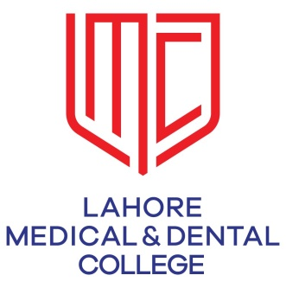

**STUDY GUIDE**

**DEPARTMENT OF RADIOLOGY**

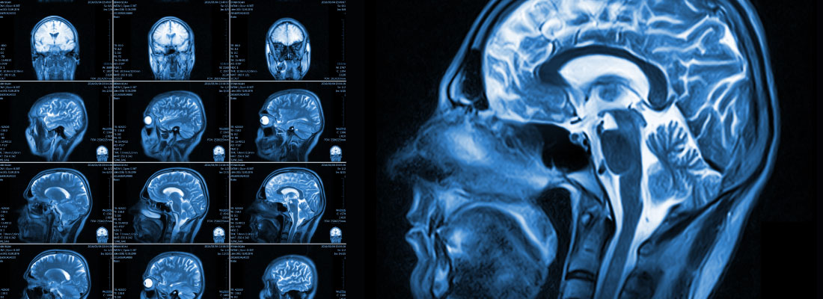

**LAHORE MEDICAL AND DENTAL COLLEGE**

**Mission of LMDC**

The Lahore Medical & Dental College is committed in its pursuit of excellence to providing the best academic facilities and atmosphere to its students.

Our mission is to: “Train future leaders of medicine who set new standards in knowledge, care and compassion”.

The well qualified and committed faculty of LMDC provides combination of nurturing support and challenge to the students to reach their maximum potential.

**TABLE OF CONTENTS**

1. **Departmental Faculty & Staff Hierarchy**
2. **Introduction / Rationale of Subject**
3. **Learning Outcomes of Subject**
4. **Content/Syllabus**
5. **Teaching & Learning Methodologies**
6. **Learning Resources**
7. **Assessments Methods**
8. **Formative and Summative Exam Rules and Regulations**
9. **Schedule/ Planner/Timetable**
10. **Counseling**
11. **Departmental Faculty & Staff Hierarchy**

**Dr. JAVAID ASGHER**

**F.A.CA. F.I.C.A**

**Diplomate American Board of Radiology**

Head of Department



**Dr. Wajeeha Imran Andrabi**

**MBBS, FCPS, FRCR**

Assistant Professor of Radiology

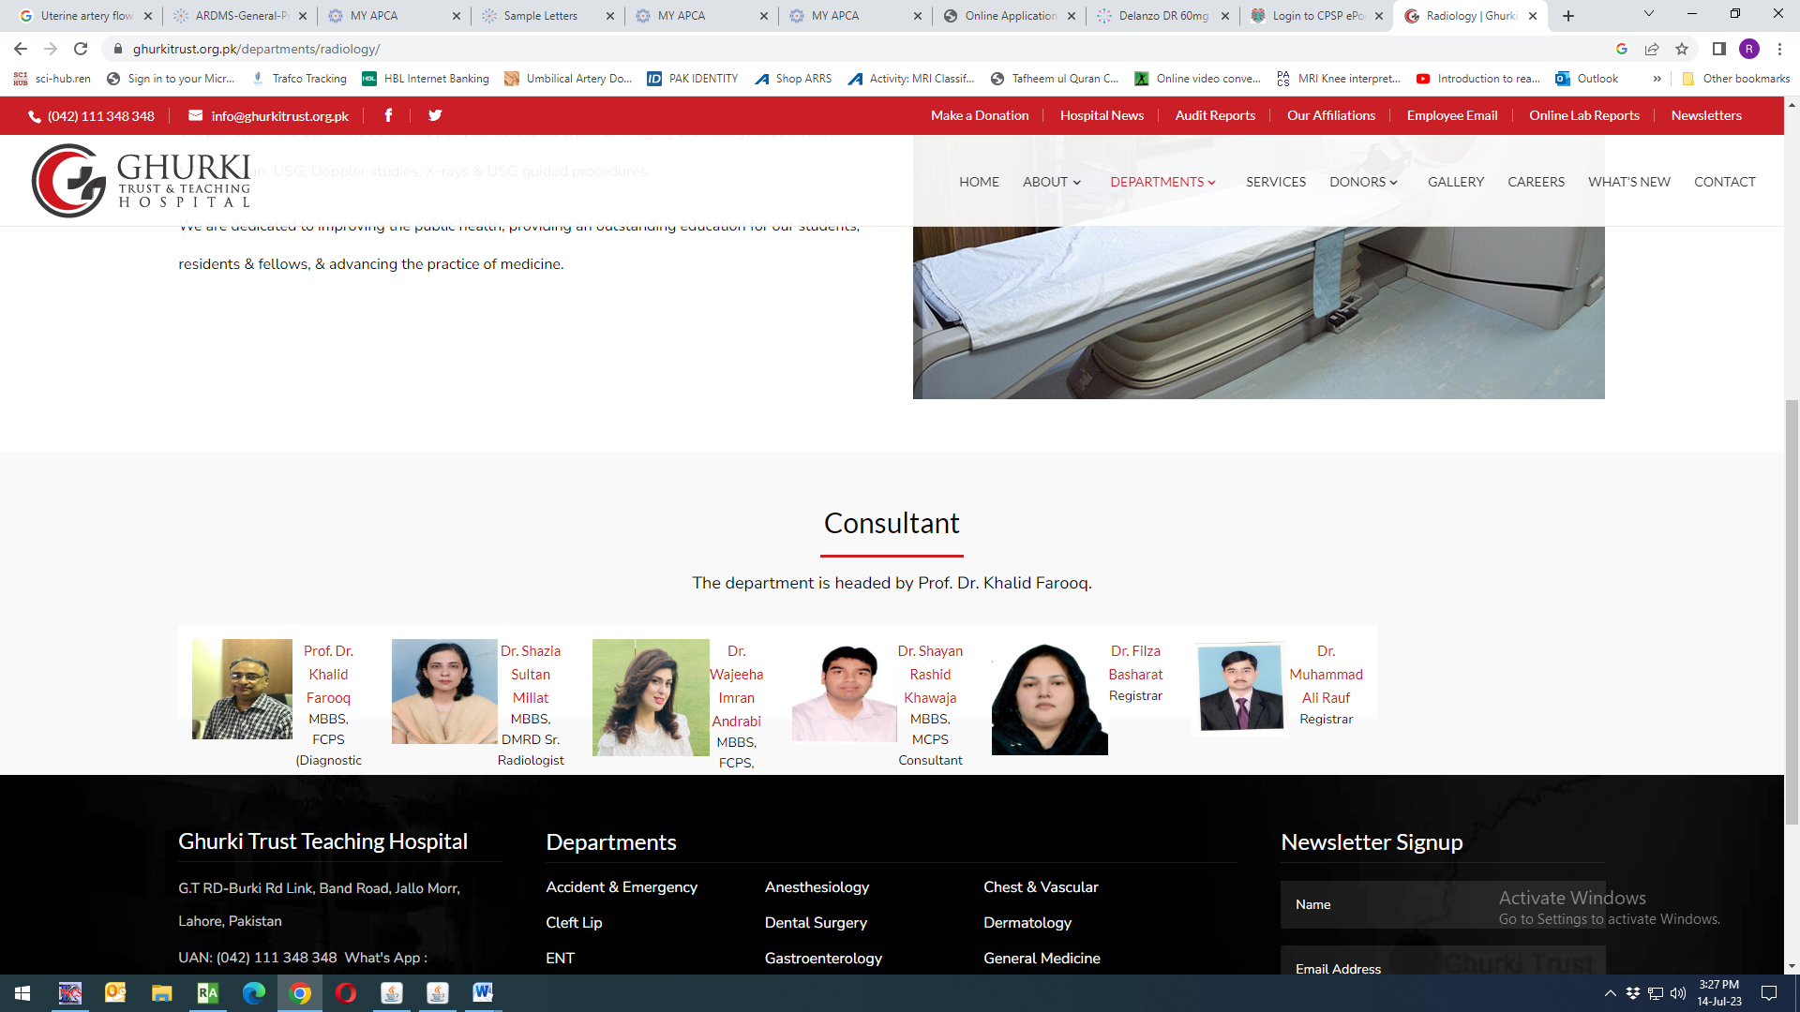

**Dr. Shazia Aleem**

**MBBS, DMRD**

Sr. Radiologist

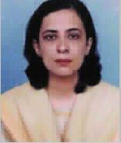

**Dr. Khalid Farooq**

**MBBS, FCPS**

Professor of Radiology

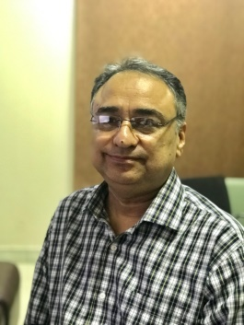

**Dr. Shayan R. Khawaja**

**MBBS, MCPS**

Consultant Radiologist

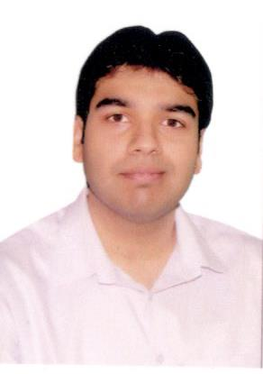

**Dr. Adeel Asghar Malik**

**MBBS, FCPS, FIR**

Interventional Radiologist

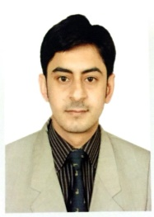

***ORGANOGRAM OF DEPARTMENT OF RADIOLOGY***

|  |  |
| --- | --- |
| **FCPS** | **MCPS** |
| Dr. Hafsa | Dr. Zaeem |
| Dr. Musab | Dr. Bushra |
| Dr. Zil-e- Rehman | Dr. Hamda |
| Dr. Syeda Rabia | Dr. Sidra Naeem |
| Dr. Maryam | Dr. Shakeela |
| Dr. Zain | Dr. Nayab |
| Dr. Tooba | Dr. Saira |
| Dr. Mishal | Dr. Mauvia |
| Dr. Sarah | Dr. Tayyaba |

|  |  |
| --- | --- |
| **Transcriptionist** | Mr. Kashif Hussain  Mr. Zaheer  Mr. Mubeen |

1. **Introduction**

Medical education is a life-long process and MBBS curriculum is a part of the continuum of education from pre-medical education, MBBS, proceeding to house job, and post-graduation. PM&DC outlines the guiding principles for undergraduate medical curriculum and has defined the generic competencies and desired outcomes for a medical graduate to provide optimal health care, leading to better health outcomes for patients and societies. These generic competencies set the standards of care for all physicians and form a part of the identity of a doctor. Each competency describes a core ability of a competent physician. This study guide will give an insight to the students about all these competencies and how to plan their educational activities in the subject of radiology for the final year period.

**TARGET AUDIENCE**

Final year MBBS students

**DURATION OF COURSE**

Total 450 hours for Radiology

___________________________________________________________________

**Total hours in 5th year MBBS= 8 hrs.**

**100 % Lectures**

10 lectures by Radiology department.

1. **Learning Outcomes of Subject**

***By the end of this academic session the students should be able,***

1. Select/advice the required radiological examination correctly
2. Identify gross abnormalities in the films
3. List indications and advantages of modern techniques
4. Recognize major abdominal viscera and their imaging characters.
5. **Content/Syllabus (PMDC / UHS)**

|  |  |
| --- | --- |
| ***Topic*** | ***Sub topics*** |
| Chest X-ray | **To understand**  •       Basic anatomy and interpretation  •       Understanding different diseases including Pneumothorax, Pneumonia, effusion, Cardiomegaly |
| Chest X-ray | **To understand**  •       Different disease including pulmonary edema, fractures, surgical emphysema, neoplastic Diseases &  chronic inflammatory disease |
| Abdomen x-ray | **To understand**  •       Normal anatomy and projections of abdomen, renal & urinary tract stones, gall stones and other calcifications, free gas under diaphragm, (perforation) |
| Spine X-ray | **To understand**  •       Normal anatomy and projections, disc space reduction, vertebral collapse |
| Barium Meal and with double contrast (where applicable) | **To understand**  •       Normal anatomy and various projections, gastric outlet obstruction, stomach mass/filling defect, colonic defects , stricture, Ulcerative colitis |
| Intravenous Urogram | **To understand**  •       Basic interpretation & hydronephrosis and renal masses interpretation. |
| Micturating Cystourethrogram | **To understand**  •       Basic interpretation & reflux pathologies |
| Cholecystogram | **To understand**  •       Basic interpretation & gall bladder diseases and stones |
|
| CT / MRI | **To Understand the**  •       Be able to interpret the report |

1. **Teaching & Learning Methodologies (Instructional Strategies)**
   1. Interactive Lectures
   2. CPC’s – using modern audio-visual techniques, distant learning using electronic devices and current Information technology facilities
2. **Learning Resources**
   1. Aids to Radiological Differential Diagnosis by Chapman S. and Nakielny R. 4th ed. Elsevier Science Limited; 2003.
   2. Online journal through LMDC library.

***Technologies to be used for Learning***

1. Textbooks are the most important part of student learning for this subject
2. Videos from different web portals to familiarize the students with the procedures and protocols.
3. Computer and Internet resources are essential to gather the latest information about a specific disease.
4. **Assessments Methods**

Class test to be taken at the end of session.

1. **Schedule/ Planner/Timetable**

**FINAL YEAR MBBS ACADEMIC PLANNER**

|  |  |
| --- | --- |
| Subject: | Radiology |
| Session | 2018-2019 |
| Total Hours | 8 |
| Total no. of lectures | 10 |
| Duration of each Lecture | 45 min. |
| Course duration: | 22-04-19 to 20-07-19 (1st June – 30th June 2019 – summer vacations) |

|  |  |  |  |
| --- | --- | --- | --- |
| ***TOTAL NO.OF Lect. No.*** | ***Topic*** | ***Sub topics*** |  |
| 1st Lecture | Chest X-ray | **To understand**  •       Basic anatomy and interpretation  •       Understanding different diseases including Pneumothorax, Pneumonia, effusion, Cardiomegaly |  |
| 2nd Lecture | Chest X-ray | **To understand**  •       Different disease including pulmonary edema, fractures, surgical emphysema, neoplastic Diseases &  chronic inflammatory disease |  |
| 3rd lecture | Abdomen x-ray | **To understand**  •       Normal anatomy and projections of abdomen, renal & urinary tract stones, gall stones and other calcifications, free gas under diaphragm, (perforation) |  |
| 4th lecture | Spine X-ray | **To understand**  •       Normal anatomy and projections, disc space reduction, vertebral collapse |  |
| 5th lecture | Barium Meal and with double contrast (where applicable) | **To understand**  •       Normal anatomy and various projections, gastric outlet obstruction, stomach mass/filling defect, colonic defects , stricture, Ulcerative colitis |  |
| 6th lecture | Intravenous Urogram | **To understand**  •       Basic interpretation & hydronephrosis and renal masses interpretation. |  |
| 7th lecture | Micturating Cystourethrogram | **To understand**  •       Basic interpretation & reflux pathologies |  |
| 8th lecture | Cholecystogram | **To understand**  •       Basic interpretation & gall bladder diseases and stones |  |
|  |
| 9th lecture | CT / MRI | **To Understand the**  •       Be able to interpret the report |  |
| 10th lecture | Test | **Test Session** |  |

1. **Counseling**
   1. Senior faculty members of Radiology department are actively involved in resolving academic and non-academic issues of allocated students.
   2. Individual students are also referred to the student counselor, if needed

**………………………………..**