

**DEPARTMENT OF DERMATOLOGY**

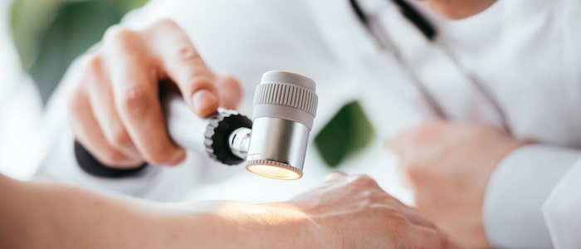

**LAHORE MEDICAL AND DENTAL COLLEGE**

**CONTENTS**

1. Introduction
2. Purpose of Guide
3. Target Audience
4. Learning Audiences
5. Learning Objectives
6. Teaching methodologies for Dermatology
7. Attendance requirement for medicine and allied
8. Duration of session
9. Departmental staff hierarchy/ plan
10. Alignment of education with study hours (Final year MBBS)
11. Content/Syllabus (PMDC)
12. Departmental time tables
13. Teaching & Learning Methodologies
14. Learning Resources
15. Assessments Methods
16. Table of specification for dermatology exam
17. Online teaching
18. Robust feedback systems
19. Counselling facilities for students

**INTRODUCTION**

Medical education is a life-long process and MBBS curriculum is a part of the continuum of education from pre-medical education, MBBS, proceeding to house job, and post-graduation. PM&DC outlines the guiding principles for undergraduate medical curriculum and has defined the generic competencies and desired outcomes for a medical graduate to provide optimal health care, leading to better health outcomes for patients and societies. These generic competencies set the standards of care for all physicians and form a part of the identity of a doctor. Each competency describes a core ability of a competent physician. This study guide will give an insight to the students about all these competencies and how to plan their educational activities in the subject of dermatology for final year.

**PURPOSE OF GUIDE:**

To facilitateundergraduate students to learn the subject of Dermatology in an effective manner,by enlightening them regarding organization of the learning program, guides students in managing their studies through the academic year and guidance on assessments methods, exam rules and regulations.

**TARGET AUDIENCE**

5th year MBBS students

**LEARNING OBJECTIVES *(knowledge, skills, attitude)***

1. to equip the students with specific knowledge, essential skills and appropriate attitude towards the human body
2. to become problem solvers, dealing effectively with familiar and unfamiliar problems
3. to become lifelong learners
4. to direct their own learning and evaluate this activity
5. to be able to reason critically and make justifiable decisions regarding patient management
6. to practice evidence-based medicine
7. to always ensure patient safety
8. to ensure compliance with the legal system as it impacts health care and the PM&DC regulations
9. to adopt a multidisciplinary approach for health promoting interventions
10. Medical graduates should be able to demonstrate professional values of self and professional accountability, honesty, probity, and ethics
11. Medical and dental graduates are expected to demonstrate exemplary professional conduct
12. to be able to understand the pathogenesis of specific diseases
13. to be able to take a thorough focused history and identify the patient’s risk factors related to the disease process
14. to be able to perform a physical examination on a patient, to diagnose specific diseases and rule out other diseases
15. to formulate a provisional diagnosis with justification, and the likely differential diagnoses
16. to be able to select appropriate hematological, biochemical and microbiological investigations and interpret their reports to confirm the diagnosis
17. to be able to select specific radiological investigations for specific diseases
18. to be able to apply evidence-based medicine concepts for the medical treatment of different diseases
19. to be able to write prescriptions in appropriate format according to the disease

**TEACHING METHODOLOGIES FOR DERMATOLOGY**

1. Interactive Lectures
2. Student presentations
3. Case based learning (CBL)
4. Tutorials
5. Essential Skills learned in department
6. Small group discussions
7. Clinical ward rotations
8. CPC’s – using modern audio-visual techniques, distant learning using electronic devices and current Information technology facilities
9. Journal Club meetings
10. Self-directed learning is the most vital part of this module to solve problematic cases, go through different learning resources and discuss with peers and the faculty to clarify difficult concepts

**ATTENDANCE REQUIREMENT FOR MEDICINE AND ALLIED**

1. Students are expected to attend all scheduled teaching sessions and examinations
2. Attendance in lectures, tutorials, and wards is mandatory. Absence from these sessions will make the students ineligible to sit the final summative assessment.
3. A minimum of 75 % attendance in the lectures and wards is mandatory to appear in the summative UHS examination
4. Attendance will be recorded through a log-in/log-out biometrics system
5. Absence due to illness must be certified appropriately by the General Physician

**DURATION OF SESSION:**

MARCH 2023- NOVEMBER 2023

**DEAPARTMENTAL CONSULTANTS / HIERARCHY PLAN**

Dermatology department teaching staff consists of:

1.Professor Haroon Nabi (Head of Department)

2.Dr. Talat Masood Akbar (Associate Professor)

3.Dr. Sumaira Hanif (Assisstant Professor)

**COURSE TO BE STUDIED (syllabus)**

The course outline is as follows:

The students will be taught all these topics.

By the end of final year, medical students should be able to identify and discuss the common causes of common clinical presentations. Causes in detail can be discussed under various other headings.

|  |
| --- |
| **Introduction and Basics of Dermatology** |
| Introduction and History taking |
| Anatomy and Physiology of Skin |
| Basic skin lesions |
| **Itchy Dermatosis** |
| Scabies |
| Pediculosis |
| Urticaria |
| Eczemas |
| Seborrheic dermatitis |
| Contact dermatitis |
| **Papulosquamous disorders** |
| Psoriasis |
| Erythroderma |
| Lichen planus |
| **Disorders of sebaceous glands** |
| Acne vulgaris |
| Rosacea |
| **Bullous disorders** |
| Pemphigus |
| Pemphigoid |
| Dermatitis herpetiformis |
| Erythema multiforme |
| SJS/TEN |
| **Infections** |
| Bacterial infections (Staphylococcal/Streptococcal) |
| Fungal infections |
| Viral infections |
| Leishmaniasis |
| Cutaneous Tuberculosis |
| Leprosy |
| **Skin and cutaneous manifestations of  systemic disorders** |
| Systemic lupus erythematosus |
| Systemic sclerosis |
| Dermatomyositis |
| Diabetes |
| **Hair disorders** |
| Alopecia |
| Telogen effluvium |
| **Pigmentary disorders** |
| Vitiligo |
| Melasma |
| **Cutaneous Malignancies** |
| Squamous cell carcinoma |
| Basal cell carcinoma |
| Malignant melanoma |

**ASSESSMENT METHODOLOGY**

***Formative***

**Theory,** single best multiple choice questions at the end of each topic completed. MCQs and SEQs for all topics tests at end of session.

**Clinical ward test,** comprising of 10 MCQs,1 SEQ and viva voce contributed by ward attendance and histories taken

Total marks= 100

**Summative UHS examination (to be held at the end of 5th year MBBS)**

Dermatology will be a part of Paper-II (medicine).

It will include: 1. Introduction and Basics of Dermatology 2. Itchy dermatosis 3.Papulosquamous disorders 4. Disorders of sebaceous glands 5. Bullous disorders 6. Infections 7. Skin and cutaneous manifestations of systemic disorders 8. Hair disorders 9. Pigmentary disorders 10.Cutaneous Malignancies.

**Summative examination details**

Dermatology will be a part of Medicine paper-II The paper will have the portion of Dermatology in the following pattern

**6 MCQs……1 marks each**

**1 SEQ……...5 marks each**

**TIMETABLE 5th Year MBBS**

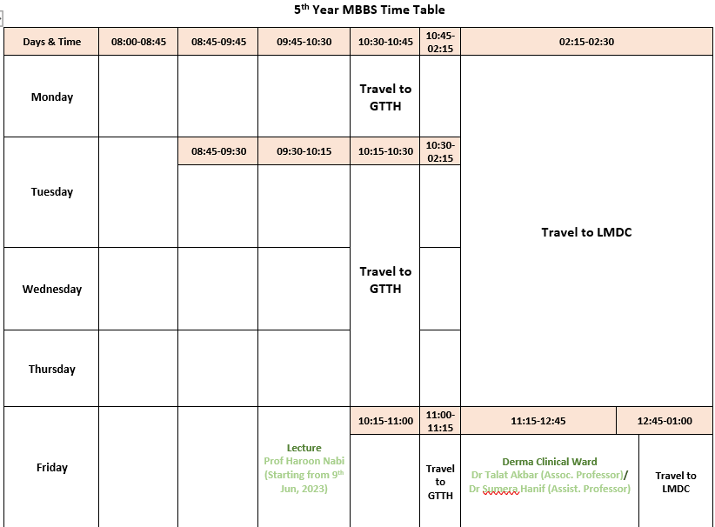 **Timetable**

**LEARNING RESOURCES**

***Recommended books***

1. ABC of Dermatology by Prof.Tahir Saeed Haroon.
2. Davidson’s Principles and Practices of Medicine.
3. Kumar and Clark’s Clinical medicine.
4. Fitzpatrick,s Colour Atlas and synopsis of Dermatology.

***Technologies to be used***

1. Textbooks are the most important part of student learning for this subject
2. Bed side learning with patients
3. Hands-on activities and practical sessions to enhance the learning.
4. Skills lab will be used for simulated learning of the basic skills related to the skin
5. Videos and slides from different web portals to familiarize the students with the procedures and protocols.
6. Computer and Internet resources are essential to gather the latest information about a specific disease.

**TABLE OF SPECIFICATION FOR MEDICINE EXAM**

**Dermatology will be included in medicine-II. 1 SEQ and 6 MCQs will be the part of the paper.**

|  |  |  |
| --- | --- | --- |
| S.NO | TOPIC | MCQs |
| 1 | **Introduction and basics of dermatology** | 01 |
| 2 | **Itchy dermatosis** | 01 |
| 3 | **Infections** | 01 |
| 4 | **Bullous disorders /Disorders of sebaceous glands/ Pigmentary disorders** | 01 |
| 5 | **Papulosquamous disorders /Hair disorders** | 01 |
| 6 | **Cutaneous Malignancies** | 01 |

**\*1 SEQ will come from any of the aforementioned topics**

**ONLINE TEACHING**:

* During covid-19 pandemic, teaching was continued online for Final Year MBBS. Online time tables were formulated by consensus of all the concerned departments. Students, faculty and concerned staff was optimally trained and facilitated by IT and DME.
* Lectures and clinical (Bedside) teaching were held using google meet and Microsoft teams. Class tests were conducted in google class room.
* Assignments, hand-outs, and other necessary information were shared on web portal of LMDC, google class room and Microsoft teams.
* Online tests were conducted using zoom software program.
* Online attendance record was meticulously maintained and added to the total record.
* In case of lockdown or any such crisis similar strategies would be employed for both synchronous and asynchronous e-learning program.

**ROBUST FEEDBACK SYSTEMS:**

* Feedback on attendance report is forwarded to students and parents on daily basis.
* Feedback on academic performance: Academic performance report is also regularly forwarded to students and parents.
* Individual students are given feedback on their academic performance in one to one session.
* MCQ and SEQ papers are also discussed with students in small groups. Parents of weak students are regularly contacted.

**COUNSELLING FACILITIES FOR STUDENTS:**

* Senior faculty members of Dermatology department are actively involved in resolving academic and non-academic issues of allocated students.
* Individual students are also referred to the student counsellor, if needed