

DEPARTMENT OF UROLOGY 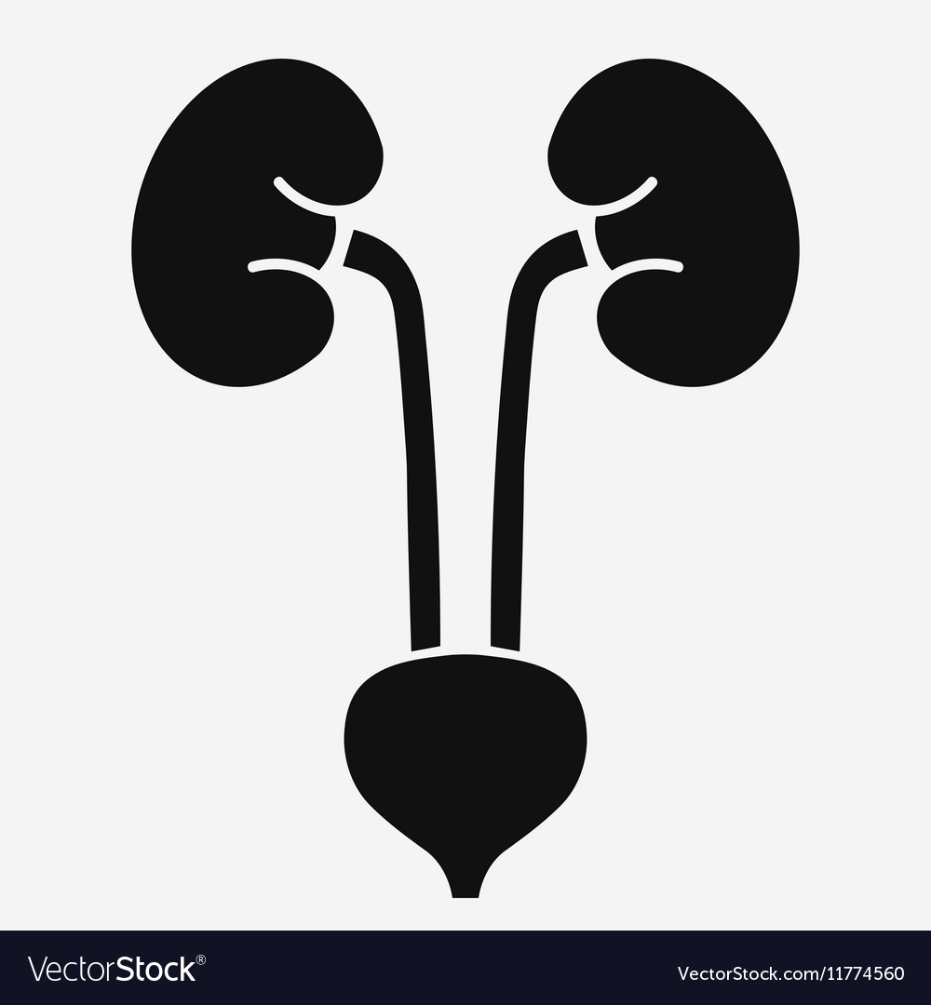

LAHORE MEDICAL AND DENTAL COLLEGE

Study Guide, Department of Urology, 2023

Mission of LMDC

The Lahore Medical & Dental College is committed in its pursuit of excellence to providing the best academic facilities and atmosphere to its students.

Our mission is to: “ Train future leaders of medicine who set new standards in knowledge, care and compassion”.

The well qualified and committed faculty of LMDC provides a combination of nurturing support and challenge to the students to reach their maximum potential.

Department of Urology

Hierarchy

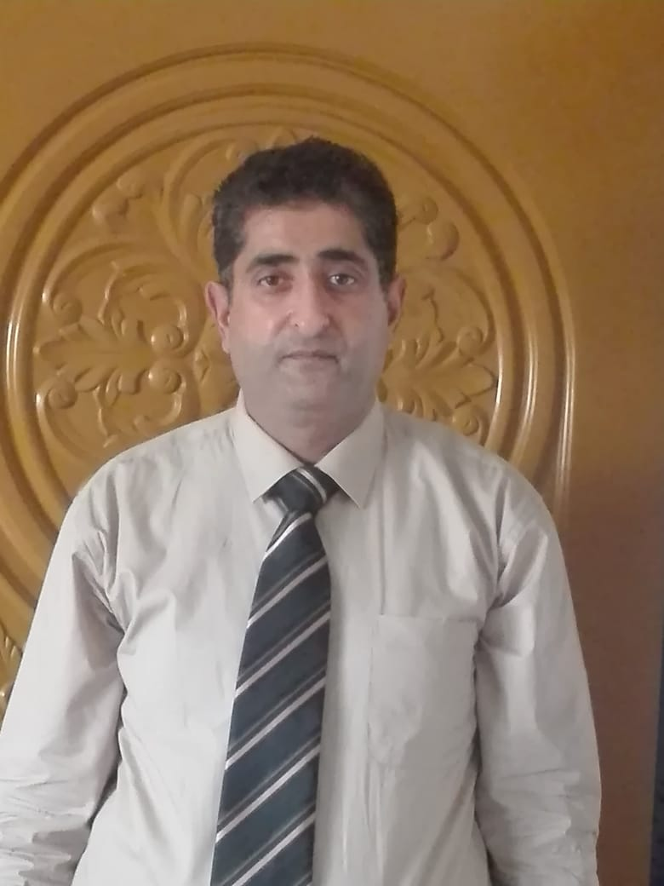

Associate Professor:

1. Dr. Nauman Bashir

FCPS ( Urology ), MCPS, MBBS ( Gen. Surgery )

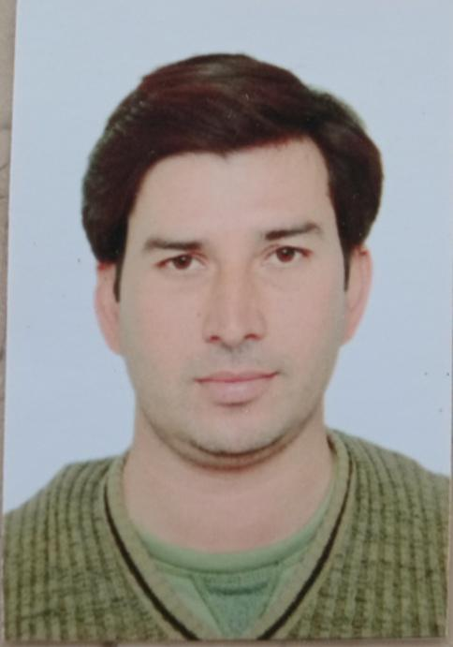

Medical Officers:

1. Dr. Falak Sher

MBBS

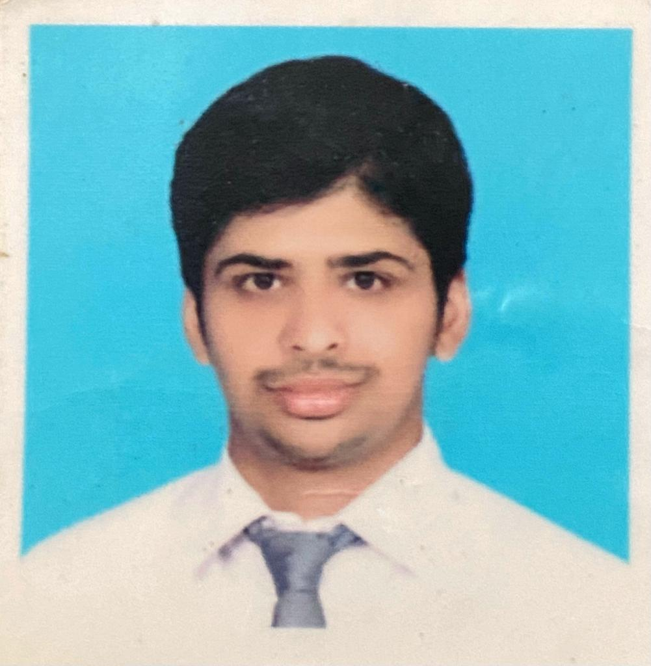

1. Dr. Mohsin

MBBS



House Officer:

1. Dr. Meran

MBBS

| STUDY GUIDE FOR UROLOGY  FOR MBBS STUDENTS |
| --- |

**INTRODUCTION:**

Medical education is a life-long process and MBBS curriculum is a part of the continuum of education from pre-medical education, MBBS, proceeding to house job, and post-graduation. PM&DC outlines the guiding principles for undergraduate medical curriculum and has defined the generic competencies and desired outcomes for a medical graduate to provide optimal health care, leading to better health outcomes for patients and societies. These generic competencies set the standards of care for all physicians and form a part of the identity of a doctor. Each competency describes a core ability of a competent physician. This study guide will give an insight to the students about all these competencies and how to plan their educational activities in the subject of urology for the fifth year of MBBS.

**TARGET AUDIENCE:**

5th year (final year) MBBS students.

**LEARNING OBJECTIVES**

***(knowledge, skills, attitude)***

***By the end of this urology ward rotation the students should be able***

1. to acquire specific knowledge, essential skills and appropriate attitude towards the human body
2. to become problem solvers, dealing effectively with familiar and unfamiliar problems
3. to become lifelong learners
4. to direct their own learning and evaluate this activity
5. to be able to reason critically and make justifiable decisions regarding patient management
6. to practice evidence-based medicine
7. to always ensure patient safety
8. to ensure compliance with the legal system as it impacts health care and the PM&DC regulations
9. to adopt a multidisciplinary approach for health promoting interventions
10. Medical graduates should be able to demonstrate professional values of self and professional accountability, honesty, and ethics
11. Medical and dental graduates are expected to demonstrate exemplary professional conduct
12. to be able to understand the pathogenesis of specific diseases
13. to be able to take a focused history and identify the patient’s risk factors related to the disease process
14. to be able to perform a physical examination on a patient, to diagnose specific urological diseases and differentiate from other systems
15. to formulate a provisional diagnosis with justification, and the likely differential diagnoses
16. to be able to select appropriate biochemical investigations and interpret their reports to confirm the diagnosis
17. to be able to select specific radiological investigations for specific diseases
18. to be able to apply evidence-based medicine concepts for the medical treatment of different diseases
19. to be able to describe the required urological procedures for different diseases

**TEACHING METHODOLOGIES FOR UROLOGY:**

1. Interactive Lectures.
2. Tutorials.
3. Bedside teaching.
4. Essential Skills to be learned in the skills lab.
5. Powerpoint presentations by students.
6. Teaching of surgical procedures in Operation theaters.
7. Clinical ward rotations.
8. CPC’s – using modern audio-visual techniques, distant learning using electronic devices and current Information technology facilities.
9. Journal Club meetings.
10. Self-directed learning is the most vital part to solve problematic cases, go through different learning resources and discuss with peers and the faculty to clarify difficult concepts.

**MBBS ACADEMIC PLANNER (Final year MBBS) FOR UROLOGY**

**SESSION 2023**

| Subject: | Urology |
| --- | --- |
| Session: | 2023-2024 |
| Total Hours: | 24 |
| Total no. of lectures: | 32 |
| Total duration of each lecture: | 45 minutes |
| Course duration: | 2023 |

**FACILITATORS:**

Associate Prof. Mohammad Nauman

| **LECT. NO.** | **PROPOSED TIMELINE** | **CHAPTER** | **TOPICS** |
| --- | --- | --- | --- |
| 1 | Week 1 | Introduction to Urology | * Brief history of Urology |
| 2 | Week 2 | Anatomy of kidney, ureter, bladder, prostate, testis | * Anatomy of kidney * Anatomy of ureter * Anatomy of bladder and function of bladder * Anatomy of testis * Anatomy of prostate |
| 3 | Week 3 | Symptoms in urology | * Symptoms of kidney disorders * S/O Ureter disorders * S/O Bladder disorders * Testicular symptoms * Prostate symptoms |
| 4 | Week 4 | Urolithiasis | * Pathogenesis * Diagnosis * Treatment |
| 5 | Week 5 | Prostate enlargement | * International Prostate Symptoms Score * Diagnosis * Treatment options – medical and surgical * New modalities |
| 6 | Week 6 | Prostate enlargement | * International Prostate Symptoms Score * Diagnosis * Treatment options – medical and surgical * New modalities |
| 7 | Week 8 | CA – Prostate | * Classical presentation * Diagnosis * Treatment for local tumor in locally advanced metastasis * Follow up |
| 8 | Week 9 | CA - Urinary Bladder | * Diagnosis * Tumor markers * Treatment * Follow up |
| 9 | Week 10 | CA - Urinary Bladder | * Benign / malignant * Diagnosis * Treatment * Follow up |
| 10 | Week 11 | CA-Testis | * Classification * Grading * Management |
| 11 | Week 12 | Renal Tumors | * Classification * Grading * Management |
| 12 | Week 14 | Urinary Bladder Trauma | * Classification * Grading * Management |
| 13 | Week 19 | Renal Trauma | * Symptoms/presentation * Diagnosis * Management * Complications |
| 14 | Week 20 | Penile Trauma | * Presentation * Diagnosis * Management * Complications |
| 15 | Week 21 | Testicular Trauma | * Presentation * Diagnosis * Management * Complications |
| 16 | Week 22 | Testicular Torsion | * Classification * GFR measurement * management |
| 17 | Week 24 | Varicocele | * Presentation * Diagnosis * Management * Complications |
| 18 | Week 25 | Vascular Access | * Classification * Diagnosis * Treatment |
| 19 | Week 26 | Infertility | * Classification * Diagnosis * Treatment * Management |
| 20 | Week 27 | Renal Failure | * Grading * Diagnosis * Management * Follow up |
| 21 | Week 28 | Renal Transplant | * Introduction * Indications * Contra indications * Complications |
| 22 | Week 30 | Erectile Dysfunction | * Definition * Classification * Procedure * Complication |
| 23 | Week 31 | Hypospadiasis | * Symptoms/presentation * Diagnosis * Management * Follow up |
| 24 | Week 32 | PUJ Obstruction | * Diagnosis * Management |
| 25 | Week 33 | VUR | * Diagnosis * Management |
| 26 | Week 34 | ESWL | * Diagnosis * Management |
| 27 | Week 35 | Urethral Trauma | * Classification * Diagnosis * Management |
| 28 | Week 36 | Urethral Trauma | * Diagnosis * Management |

**Technologies to be used for Learning:**

1. Textbooks are the most important part of student learning for this subject.
2. Hands-on activities and practical sessions to enhance the learning.
3. Skills lab will be used for simulated learning of the basic skills related to the gastrointestinal system.
4. Videos from different web portals to familiarize the students with the procedures and protocols.
5. Computer and Internet resources are essential to gather the latest information about a specific disease.

**UROLOGY BATCH STUDY PLAN**

**FOR MBBS FINAL YEAR 2023**

**DAYS :**

Wednesday: 10:45 AM - 2:30 PM

| Week 1 | * Introduction of urology * Urology history taking * Urological examination * Introduction of urological investigations |
| --- | --- |
| Week 2 | * Anatomy and physiology of prostate gland * Presentation of prostatic enlargement * Examination of prostate (DRE) * How to investigate a patient of prostatic enlargement * What are different treatment options (medical/surgery) * Follow up protocol |
| Week 3 | * Introduction of urolithiasis * different presentation of renal,ureteric,and urinary bladder stones * Investigations related to urolithiasis * Treatment options for different stones * Stone prevention protocol |
| Week 4 | * UTI * Classification (Simple/complicated) * Non specific and specific (genitourinary TB etc.) * Sexual transmitted infections (STI) * UTI in pregnancy |
| Week 5 | * Presentation on U bladder tumor * Examination of a patient with u bladder tumor * Investigations of u bladder tumor * Superficial and deep bladder tumors * Treatment of superficial and deep bladder tumor |
| Week 6 | * Urological Emergencies (urethral trauma,Testicular torsion) * Urological X Rays (IVU,Retrograde urethrogram) * Urological instruments (Boujies.Supra pubic trocar) * Urological Gadgets (GJ stent, Ureteric stents, Guide wires) |

**ASSESSMENT:**

**Total marks:** 100

**Passing marks:** 60%

**Eligibility criteria:** 75% attendance

**Method of assessment: OSCE:** 50% **Viva:**  50%

| **Time Table For UROLOGY**  **( MBBS FINAL YEAR)** | | |
| --- | --- | --- |
| **DAY** | **LECTURE** | **CLINICAL** |
| Monday |  |  |
| Tuesday | 8:45 AM - 9:30 AM |  |
| Wednesday |  | 10:45 AM - 2:30 PM |
| Thursday |  |  |
| Friday |  |  |

| **BATCH** |
| --- |
| D |
| C |
| F |
| E |
| B |
| A |

For career guidance & psychosocial counseling Associate Professor Dr. Nauman Bashir will be available from the Department of Urology.